## **Module 3: In Class Assignment Node Framework**

Saurabh Kale

IFT 458/554: Middleware Programming & Database Security

Dinesh Sthapit

Sep 19th, 2023

**Home page –**

**userLoginForm.ejs-**

**Created User-**

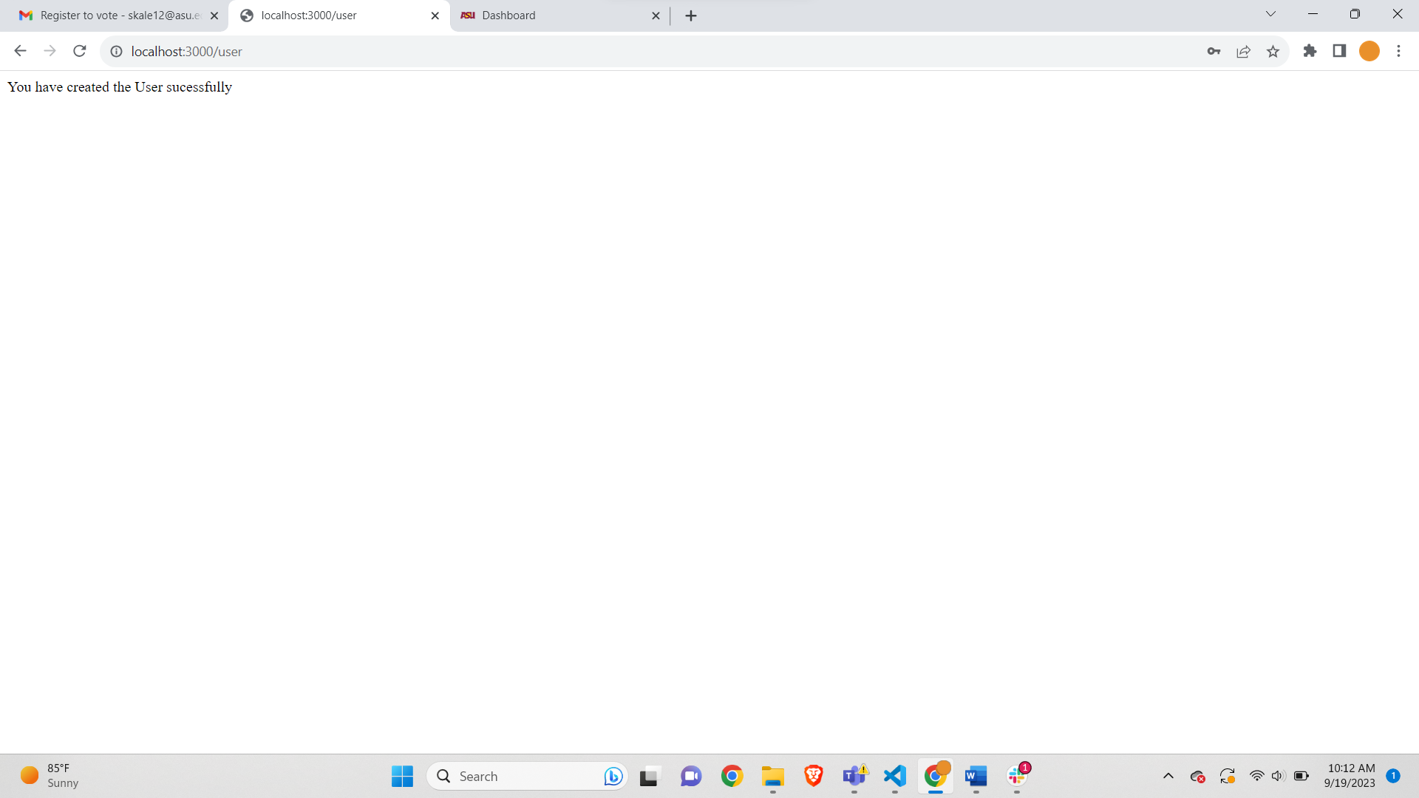

**Request Received-**

